**Class Activity: Event Handler**

1. Ready…Set…Count!

In this activity, we will be making use of onClickListeners and creating a counter with add, minus and reset functions.

First, create we will create a layout with a TextView for the counting number and 3 buttons, add, minus and reset.

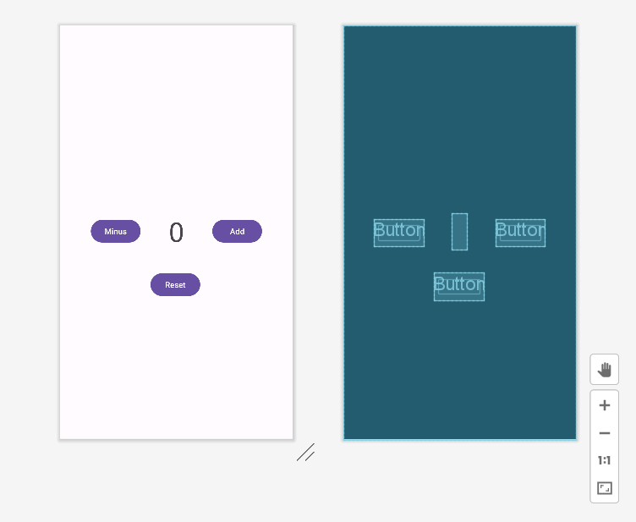

In the main activity, the default counter will be set to 0. When the user clicks on “Add”, it will add one to the counter. When the “Minus” button is clicked, it will minus one to the counter. The “Reset” button will reset the counter back to 0.

**Expected output:**

